[Array 14 (2022) 100152](https://doi.org/10.1016/j.array.2022.100152)

|  |  |  |
| --- | --- | --- |
|  |  |  |
|  | Contents lists available at ScienceDirect |  |
| Array |
| journal homepage: [www.sciencedirect.com/journal/array](https://www.sciencedirect.com/journal/array) |

Joint Multiple Fine-grained feature for Vehicle Re-Identification Yan Xu*, Leilei Rong**, Xiaolei Zhou, Xuguang Pan, Xianglan Liu   
*College of Electronic and Information Engineering, Shandong University of Science & Technology, Qingdao 266590, China*

|  |  |
| --- | --- |
| A R T I C L E I N F O | A B S T R A C T |
| *Keywords:*  Image retrieval  Deep learning  Vehicle re-identification Fine-grained feature  Feature map segmentation mINP | The process of recognizing the same vehicle in different scenes is called vehicle re-identification. However, due to the different locations of the surveillance cameras, there may be obstacles in the captured vehicle pictures and multiple viewpoints may make the same vehicle look different. In order to effectively reduce the interference of obstacle occlusion, multiple viewpoints, and other factors on vehicle re-identification, in this paper, we propose a multi-fine-grained feature extraction network. While retaining the global information of vehicles, we extract the finegrained features of vehicles precisely by segmenting the vehicle feature map. In addition, we introduce a new evaluation metric mean Inverse Negative Penalty (mINP) to evaluate the vehicle re-identification model more comprehensively. Our method achieves superior accuracy over the state-of-the-art methods on the challenging vehicle datasets: VeRi-776, VehicleID, and VRIC. |

**1. Introduction**

Vehicle re-identification (re-id) aims to identify the same vehicle from different scenes, and belongs to the subtask of image retrieval. With the promotion of deep learning technology, vehicle re- identification has become a hot topic in the field of computer vision. However, due to the production of vehicle database from different sur-veillance cameras in the real world, the captured vehicle images have interference factors such as motion blur, dark background, low resolu-tion, obstacle occlusion, multi-viewpoint, and so on. Hence, how to weaken the adverse factors and improve the accuracy of vehicle re- identification has become a key research direction in this field.

In recent years, researchers have mainly designed new network structures [1–7] based on convolutional neural networks (CNN) to learn more discriminative vehicle features or introduced additional informa-tion [8–10] to improve the performance of vehicle re-identification models. Early research [11] focused on using the global information of the vehicle to complete the re-identification task, while ignoring the local information of the vehicle. The local information contains key features that distinguish different vehicles. In order to obtain local feature information of vehicles, Liu et al. [12] proposed a region-aware deep Model (RAM), which can not only extract global features of vehi-cles but also learn discriminant features of different local regions. He et al. [13] proposed a simple and effective local regularization method, which improves the network’s ability to perceive subtle feature

differences, strengthens the network’s learning of local features, and further expands the differences between similar instances. Khorram-shahi et al. [14] adopted the idea of feature extraction from rough to fine. In the first stage, the proposed adaptive key point selection module was used to select the key points with the largest amount of information from the initial layer of the global feature extraction network to roughly extract local features around the selected key points. In the second stage, the vehicle features of the first stage are refined through the two-layer hourglass network with jump connections, and the relatively fine vehicle features obtained are used for vehicle feature matching. There-fore, using local feature information for vehicle re-identification can make the network model extract more refined vehicle features, and combine with the global features of vehicles, can significantly improve the model’s ability to distinguish vehicles with similar appearance but different identities, and improve the accuracy of vehicle re-identification. Later, scholars [15] combined global and local infor-mation together. Although it effectively improved the accuracy of vehicle re-identification, they failed to make full use of the vehicle’s local information.

To solve this problem, we divide the vehicle feature map horizontally and keep the global information of the vehicle at the same time. The advantage of convolutional neural networks lies in the perception of local information in the image. By feature map segmentation, on the one hand, it can make the feature extraction network pay more attention to the fine-grained features of the vehicle (such as vehicle logo, lights,

* Corresponding author.

** Corresponding author.

*E-mail addresses:* [x1y5@163.com](mailto:x1y5@163.com) (Y. Xu), [rong15305385721@163.com](mailto:rong15305385721@163.com) (L. Rong).

<https://doi.org/10.1016/j.array.2022.100152>   
[Received 14 October 2021; Received in revis](https://doi.org/10.1016/j.array.2022.100152)ed form 3 February 2022; Accepted 1 April 2022   
Available online 15 April 2022   
[2590-0056](http://creativecommons.org/licenses/by-nc-nd/4.0/)/© 2022 The Author(s). Published by Elsevier Inc. This is an open access article under the CC BY-NC-ND license (<http://creativecommons.org/licenses/by-nc-nd/4.0/>).

*Y. Xu et al.*  *Array 14 (2022) 100152*

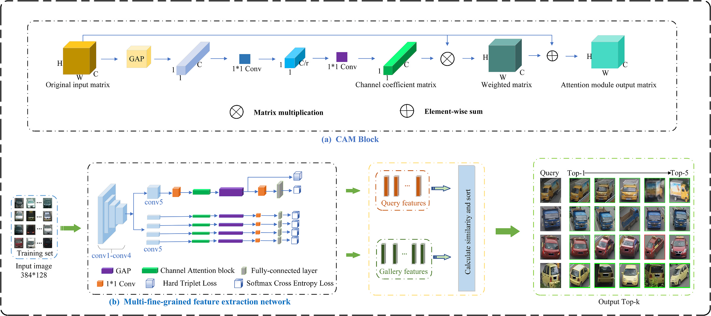

**Fig. 1.** The overall framework of the algorithm model for vehicle re-identification. (a) CAM represents a channel attention mechanism; (b) Illustration of multi-fine- grained feature extraction network. (Best view in color).

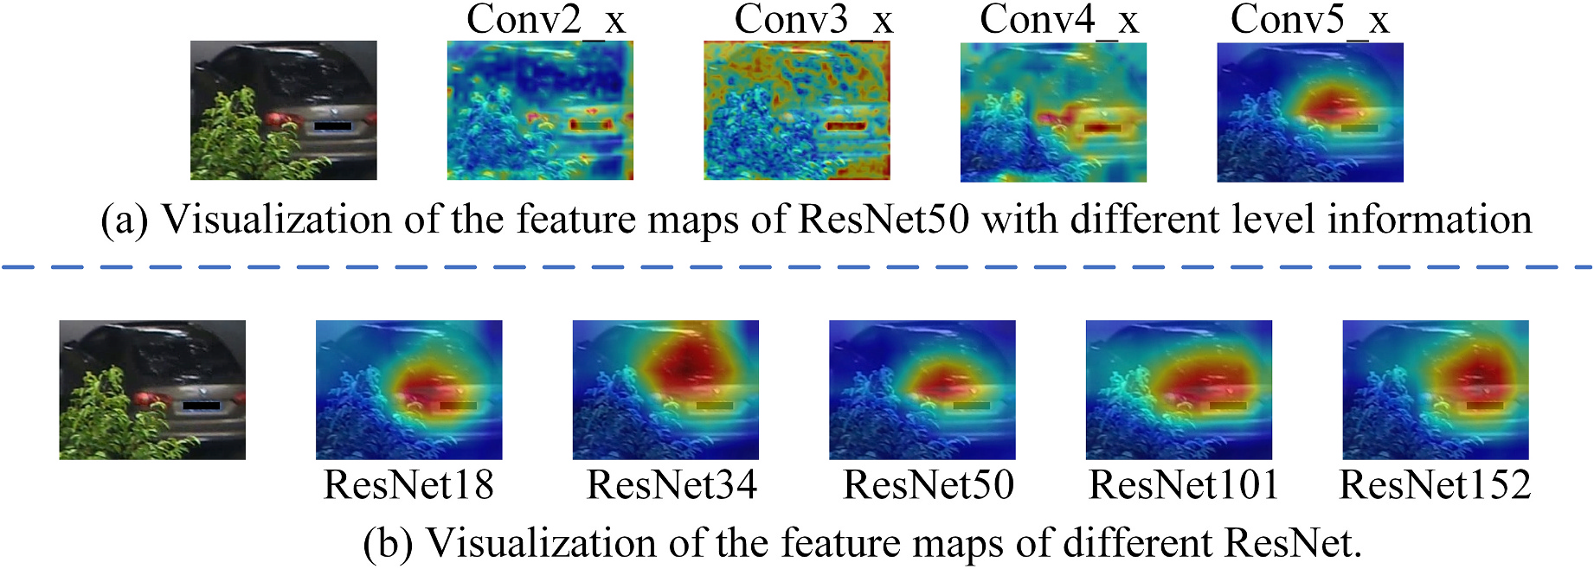

**Fig. 2.** Visualization of the feature maps of deep residual networks.

annual inspection signs, body decoration, etc.). On the other hand, it can effectively reduce the influence of obstacles and other adverse factors in the original image on vehicle feature learning. In addition, we also introduce channel attention mechanism to further strengthen the net-work’s recognition of vehicle fine-grained features after feature map segmentation. Experiments on the mainstream open datasets (VeRi-776 [16], VehicleID [17], and VRIC [18]) show that the best result is ach-ieved in the feature map quartering, as shown in Fig. 1(b).

The rest of this paper is organized as follows: Section 2 introduces the specific process of vehicle re-identification and provides an overview of multi-fine-grained feature extraction network and loss function. Section 3 introduces the new evaluation metric: mINP. Section 4 presents the experimental results and analysis, and Section 5 draws concluding remarks.

**2. Proposed method**

*2.1. The specific process of vehicle re-id*

Firstly, the image of the training set is imported into the multi-fine- grained feature network. After several iterations, the optimal model is

2

*Y. Xu et al.*  *Array 14 (2022) 100152*

**Table 1**   
The parameter and meaning of loss function.

|  |  |
| --- | --- |
| Parameter | Meaning |
| *Ni*  *Nid*  *xj*  *y*  *Ai*  *Pi*  *Nj*  *δ*  *α*  *β* | the number of vehicle images per batch  the number of vehicle identities  the output of fully connected layer for *j* th identity the ground truth identity of input vehicle image Anchor  Positive  Negative  minimal margin  Weight  Weight |

convolution module before GAP is to greatly increase the non-linear characteristics while keeping the scale of the feature map unchanged, so that the network can give full play to the advantages of depth. When 1*1 convolution module is added after GAP, the features after GAP will not go through the classification layer directly, but are fused first, and the fused features are classified. In this way, the accuracy can be greatly improved without affecting the model inference speed.

In the local branch, the vehicle feature map (h*w*c) is divided into four blocks according to its height, and the size of each block is (h/ 4*w*c), which can effectively reduce the influence of such adverse factors as occlusion on feature extraction. At the same time, we embed the channel attention module in the global branch and the local branch respectively to make the network pay more attention to the personalized characteristics of the vehicle. The working principle of this module is shown in Fig. 1(a).

During the training stage, global branch and local branch do not share the weight and train separately. But when testing, all branch in-formation will be assembled into a comprehensive feature to increase network performance.

*2.3. Loss function*

In the global branch of the MFG-Net network, we introduce two loss functions: hard mining triplet loss [20] and softmax cross-entropy loss; meanwhile, in the local branch, we only use softmax cross-entropy loss, and finally get a total loss by weighting.

|  |  |  |  |  |
| --- | --- | --- | --- | --- |
| *LSoftmax* = − | *Ni* ∑ | log (  ∑*Nid j*=1exp exp ( *xy*  ( ) *xj* | ) ) | (1) |

**3. mINP: a new evaluation metric for vehicle Re-ID**

Since the previous vehicle re-id model evaluation metrics mAP and Rank-n cannot objectively evaluate the retrieval ability of the model, we introduce a new model evaluation metric: mINP (mean Inverse Negative Penalty) [21], which is used to characterize the most difficult and cor-rect retrieval ability of the network model. So far, we are the only team that uses the ability of the sample retrieval as an indicator in the field of vehicle re-identification.

|  |  |  |
| --- | --- | --- |
| *NPi* =*Xi* ~~−~~ *Gi* | (*i* = 1*,* 2*,* …*, Q*) | (4) |
| *INPi* = 1 − *NPi* =*Gi* | | (5) |
| *mINP* =1 *Q*∑*Q* 11 − *NPi* = 1 *Q*∑*Q* 11 − *Xi* ~~−~~ *Gi*  (6)  In vehicle re-identification, G and X are the number of target vehicles in vehicle retrieval results and the number of times to retrieve the last target vehicle, respectively; X-G is the number of interfering vehicles; NP and INP are the occupations of interfering vehicles and target vehicles in retrieval results in turn. mINP represents the mean occupancy rate of Q target vehicles in the search results.  Therefore, mINP can evaluate the performance of the model more objectively and effectively avoid the dominance of simple matching in mAP/CMC evaluation. It can not only reflect the relative performance of the vehicle re-id model but also provide a supplement to the widely used mAP and CMC metrics. | | |

**4. Experiment**

*4.1. Datasets and settings*

We conduct extensive experiments on three public benchmarks for vehicle re-id, namely, **VeRi-776, VehicleID,** and **VRIC**. The details of the datasets are shown in Table 2.

In addition, the software tools are *PyTorch*, *CUDA11.1*, and *CUDNN V8.0.4.30*. The hardware device is a workstation equipped with *AMD Ryzen 5 3600X CPU 32G*, *NVIDIA GeForce RTX 3080* and 256 GB+2 TB memory.

*4.2. Evaluation protocols and implementation details*

and then enhanced by random erasure and horizontal flipping. At the During the training stage, the vehicle image is resized to 384 × 128,

same time, the *Amsgrad* optimizer is used to optimize our model. The

|  |  |  |  |  |  |  |  |  |
| --- | --- | --- | --- | --- | --- | --- | --- | --- |
| *Lhard mining triplet* = | ∑*Q i*=1 | ∑*K A*=1 | ⎡⎢⎢⎢⎢⎢⎢⎢⎣ | ⏞̅̅̅̅̅̅̅̅̅̅̅̅̅⏟⏟̅̅̅̅̅̅̅̅̅̅̅̅̅⏞*hardest positive* | − | ⏞̅̅̅̅̅̅̅̅̅̅̅̅̅̅̅̅̅̅⏟⏟̅̅̅̅̅̅̅̅̅̅̅̅̅̅̅̅̅̅⏞*hardest negative i*∕=*j* ⃦⃦*Ai* − *Nj*⃦⃦ | ⎤ ⎥⎥⎥⎥⎥⎥⎥⎦+ | (2) |

*Ltotal* = *α*\**LSoftmax* + *β*\**Lhard mining triplet*  (3)

where the meanings of the parameters of (1), (2) and (3) are listed in

Table 1.

3

*Y. Xu et al.*  *Array 14 (2022) 100152*

**Table 2**   
The details of the datasets.

|  |  |  |  |  |  |
| --- | --- | --- | --- | --- | --- |
| Dataset | VeRi-776 | VRIC | VehicleID | |  |
| Images  IDs  Training   Set/IDs Query/IDs | 51,035  776  37,778/ 576  1,678/  200  11,579/ 200 | 60,430  5,622  54,808/ 2,811  2,811/  2,811  2,811/  2,811 | 221,763  26,267  110,178/13,134 | | 17,638/ 2,400  2,400/  2,400 |
| 6,532/  800  800/800 | 11,395/ 1,600  1,600/  1,600 |
| Gallery/IDs |

**Table 3**   
The result of the horizontal division times of feature map on VeRi-776 dataset.

|  |  |  |  |
| --- | --- | --- | --- |
| Horizontal division times | mAP | mINP | R1 |
| 1  2  **3 (Ours)**  4  5 | 71.11  72.05  **77.15**  73.10  70.88 | 25.58  28.45  **36.82**  30.01  25.32 | 93.68  92.60  **96.72**  94.82  90.98 |

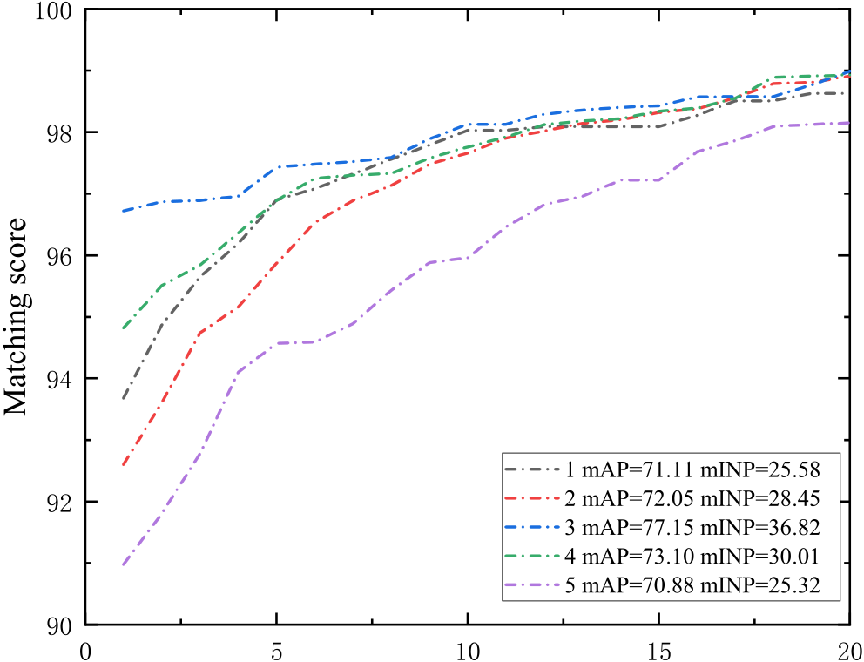



**Fig. 3.** The CMC curves of ablation study on VeRi-776 dataset.

**Table 4**   
The ablation studies result of the MFG-Net on VeRi-776 dataset.

|  |  |  |  |
| --- | --- | --- | --- |
| Method | mAP | mINP | R1 |
| Baseline  + global branch (w/o *Lhard mining triplet*) + global branch (w/ *Lhard mining triplet*) + local branch  +CAM | 62.43  68.55  70.68  75.10  **77.15** | 22.71  27.62  33.00  35.54  **36.82** | 89.70 91.17 93.78 94.88 **96.72** |

*4.3. Ablation study*

To investigate the effectiveness and contribution of the feature map horizontally quartered in our MFG-Net, we conducted ablation study on VeRi-776 dataset. The evaluation results are shown in Table 3. The CMC curve of the ablation study on this dataset is shown in Fig. 3, in which the effectiveness of the horizontal division times of the feature map is visually compared from Rank 1 to 20.

From Table 3 and Fig. 3 we can see, the feature map horizontally quartered (the number of horizontal divisions is equal to 3) surpasses the others. The comparison results show that the feature map horizontally quartered is more suitable for fully extracting the fine-grained features

4

*Y. Xu et al.*  *Array 14 (2022) 100152*

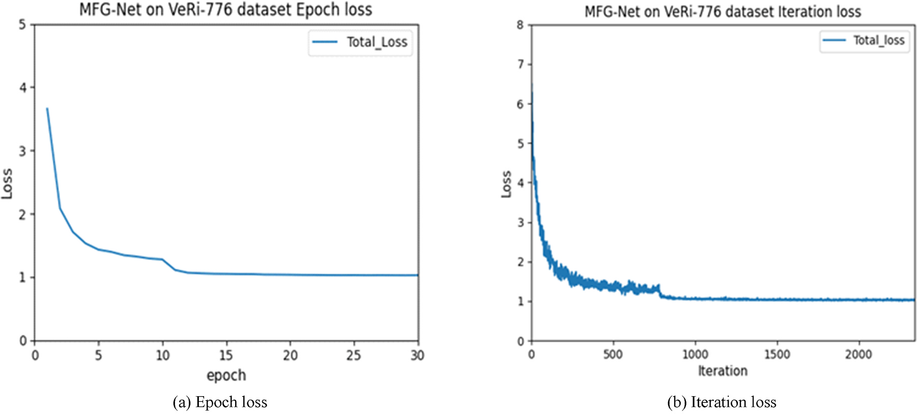

**Fig. 4.** The training loss of MFG-Net on VeRi-776.(a) Epoch loss. (b) Iteration loss.

**Table 5**   
Comparison with state-of-the-art methods on VeRi-776.

|  |  |  |  |
| --- | --- | --- | --- |
| Methods | mAP | mINP | Rank1 |
| DAVR [1]  VRSDNet [22]  VAMI + ST [2]  RAM [12]  GRF + GGL [15]  BS [23]  CCA [3]  MRM [4]  SPAN w/CPDM [24] TCL + SL [25]  MsDeep [5]  UMTS [26]  **MFG-Net** | 52.36  53.45  61.32  61.50  61.7  67.55  68.05  68.55  68.9  68.97  74.50  75.9  **77.15** | –  –  –  –  –  –  –  –  –  –  –  –  **36.82** | 83.25  83.49  85.92  88.60  89.4  90.23  91.71  91.77  94.0  93.92  95.10  95.61  **96.72** |

*4.6. VRIC*

During the training stage on VRIC, the learning rate is decreased by a factor of 0.1 after the 15*th* and 30*th* epoch, till the end 40*th* epoch. And the batch-size of training and testing are both 32. The training loss of

MFG-Net on VRIC is shown in Fig. 6.

To further validate our proposed method, we carry out experiments on the VRIC dataset, which contains more challenging training examples.

It can be seen from Table 7 that the performance of our method MFG- Net is better than all other methods listed in Table 7 including MSVF [18], GLAMOR [6], BS [23] and PGAN [7] on mAP and Rank1 metric. In addition, mINP reaches 55.81% and shows that our model has better retrieval capabilities.

**5. Discussion**

In our work, we mainly use feature map segmentation combined with channel attention mechanism to extract multiple fine-grained features of vehicles to improve the accuracy of vehicle re-id. Differ from what we think [24,28,29], adopt feature alignment to adjust the image to the same scale, which is conducive to similar feature matching.

Finally, these methods enhance the performance of re-id model.

In order to prove the robustness and generalization of the MFG-Net, our retrieval results are visualized on VeRi-776, VRIC and VehicleID, as shown in Fig. 7. We can see that the MFG-Net is more robust and generalized to vehicles in different poses.

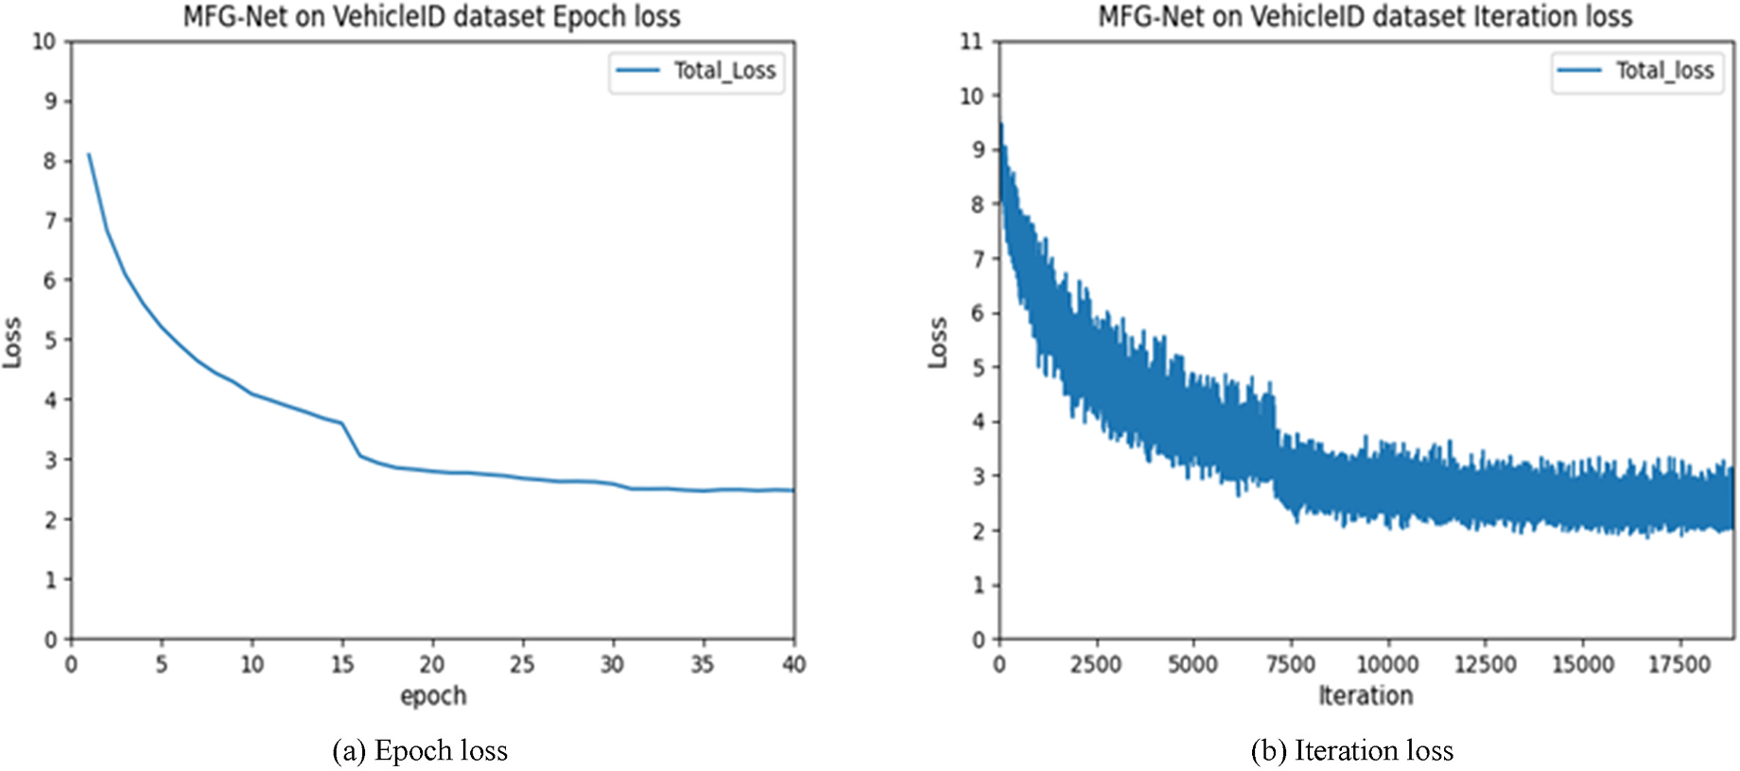

**Fig. 5.** The training loss of MFG-Net on VehicleID. (a) Epoch loss, (b) Iteration loss.

5

*Y. Xu et al.*  *Array 14 (2022) 100152*

**Table 6**

Comparison with state-of-the-art methods on VehicleID.

|  |  |  |  |  |  |  |  |  |  |
| --- | --- | --- | --- | --- | --- | --- | --- | --- | --- |
| Methods | Test800 |  |  | Test1600 |  |  | Test2400 |  |  |
|  | mAP | mINP | Rank1 | mAP | mINP | Rank1 | mAP | mINP | Rank1 |
| VAMI [2]  DAVR [1]  RAM [12]  CCA [3]  MRM [4]  TCL + SL [25]  GRF + GGL [15] MSA [27]  BS [23]  MsDeep [5]  **MFG-Net** | –  72.40 | –  –  –  –  –  –  –  –  –  –  **68.32** | 63.12  68.04  75.20  75.51  76.64  74.97  77.1  77.55  78.80  81.20  **82.02** | –  70.11 | –  –  –  –  –  –  –  –  –  –  **64.38** | 52.87  66.48  72.30  73.60  74.20  72.84  72.7  74.41  73.41  78.00  **78.69** | –  67.97 | –  –  –  –  –  –  –  –  –  –  **60.03** | 47.34  64.07  67.70  70.08  70.86  71.20  70.0  72.91  69.33  75.60  **75.16** |
| –  78.89  80.02  80.13 | –  76.53  77.32  77.26 | –  73.11  74.02  75.25 |
| –  80.31 86.19 84.30 **88.37** | –  77.11  81.69  81.00  **84.70** | –  75.55  78.16  78.60  **81.01** |

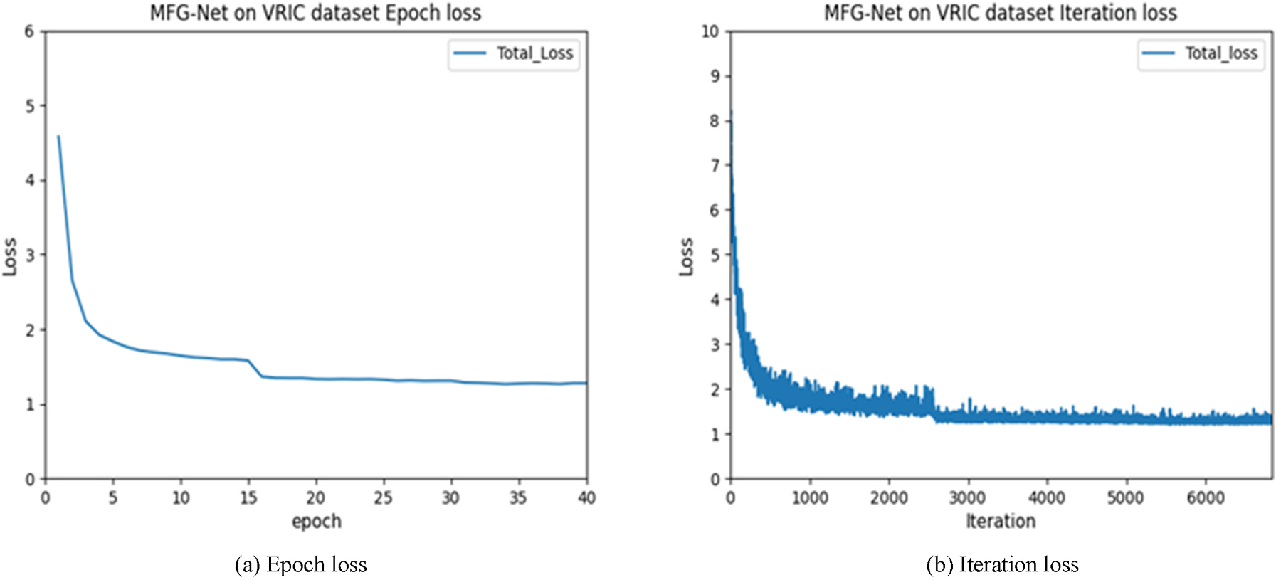

**Fig. 6.** The training loss of MFG-Net on VRIC. (a) Epoch loss. (b) Iteration loss.

**Table 7**   
Comparison with state-of-the-art methods on VRIC.

|  |  |  |  |
| --- | --- | --- | --- |
| Methods | mAP | mINP | Rank1 |
| MSVF [18]  GLAMOR [6] BS [23]  PGAN [7]  **MFG-Net** | 47.50  76.48  78.55  84.80  **84.86** | –  –  –  –  **55.81** | 46.61  75.58  69.09  78.00  **79.56** |

**6. Conclusion**

This paper presents an effective multi-fine-grained feature extraction network for vehicle re-identification. Using the proposed MFG-Net, the fine-grained features of the vehicle can be fully utilized, which provides robustness against vehicle obstructions. Our experiments show that the proposed MFG-Net is superior to multiple state-of-the-art vehicle re- identification methods on VeRi-776, VehicleID and VRIC datasets. In addition, we introduce a new evaluation metric: mINP. The experi-mental verification not only confirms the retrieval ability of our model, but also verifies the effectiveness of the new metric.

In the future, we will not only enrich the types of vehicles, but also

6

*Y. Xu et al.*  *Array 14 (2022) 100152*

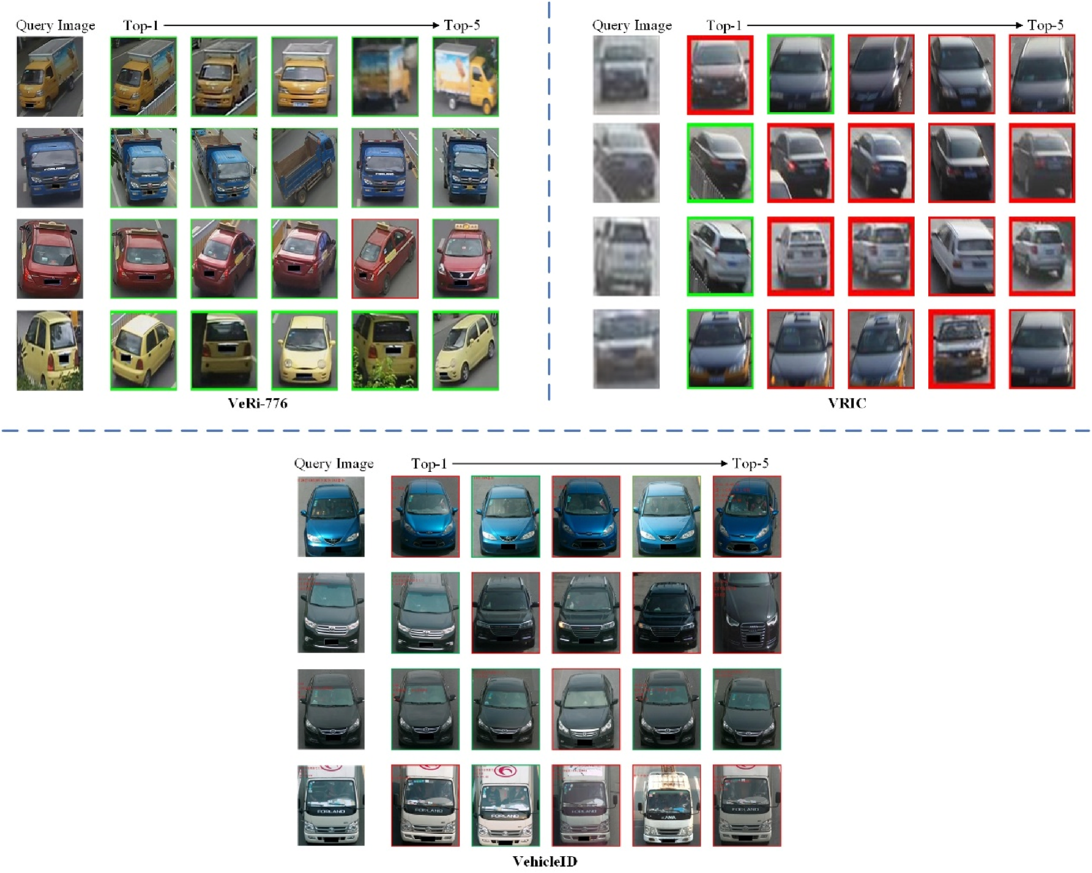

**Fig. 7.** Visualization of MFG-Net retrieval results on VeRi-776, VRIC and VehicleID. The green and red boxes represent correct matching vehicles and wrong

matching vehicles, respectively.

**References**

[1] Peng J, Wang H, Xu F, Fu X. Cross domain knowledge learning with dual-branch adversarial network for vehicle re-identification. Neurocomputing 2020;401: 133–44. <https://doi.org/10.1016/j.neucom.2020.02.112>.

[2] Zhou Y, [Shao L. Viewpoint-aware attentive multi-view i](https://doi.org/10.1016/j.neucom.2020.02.112)nference for vehicle Re- identification. In: IEEE comput soc conf comput vision pattern recognit; 2018. p. 6489–98. <https://doi.org/10.1109/CVPR.2018.00679>.

[3] Peng J, Jiang [G, Chen D, Zhao T, Wang H. Eliminating cro](https://doi.org/10.1109/CVPR.2018.00679)ss-camera bias for vehicle re-identification. Multimed Tool Appl 2020:1–17. [https://doi.org/10.1007/](https://doi.org/10.1007/s11042-020-09987-z) [s11042-020-09987-z](https://doi.org/10.1007/s11042-020-09987-z).

[4] [Peng J, Wang H, Zh](https://doi.org/10.1007/s11042-020-09987-z)ao T, Fu X. Learning multi-region features for vehicle re- identification with context-based ranking method. Neurocomputing 2019;359: 427–37. <https://doi.org/10.1016/j.neucom.2019.06.013>.

[5] Cheng Y, [Zhang C, Gu K, Qi L, Gan Z. Multi-scale deep fea](https://doi.org/10.1016/j.neucom.2019.06.013)ture fusion for vehicle Re- identification. In: IEEE int conf acoust speech signal process proc; 2020.

p. 1928–32. <https://doi.org/10.1109/ICASSP40776.2020.9053328>.

[6] Suprem A, P[u C. Looking GLAMORous: vehicle Re-id in heterogen](https://doi.org/10.1109/ICASSP40776.2020.9053328)eous cameras networks with global and local attention. arXiv preprint arXiv:2002.02256, [htt](https://arxiv.org/abs/2002.02256) [ps://arxiv.org/abs/2002.02256](https://arxiv.org/abs/2002.02256); 2020.

[7] [Zhang X, Zhang R, Cao J, Gong](https://arxiv.org/abs/2002.02256) [D, You M. Part-guided attention learning for vehicle](http://refhub.elsevier.com/S2590-0056(22)00020-0/sref7) [re-identification. 2019. arXiv preprint arXiv:1909.06023.](http://refhub.elsevier.com/S2590-0056(22)00020-0/sref7)

[8] [Shen Y, Xiao T, Li H, Yi S. Learning deep neural networ](http://refhub.elsevier.com/S2590-0056(22)00020-0/sref7)ks for vehicle re-id with visual-spatio-temporal path proposals. IEEE Int Conf Comput Vision 2017:1900–9. <https://doi.org/10.1109/ICCV.2017.210>.

[9] [Jiang N, Xu Y, Zhou Z, Wu W. Multi-attr](https://doi.org/10.1109/ICCV.2017.210)ibute driven vehicle re-identification with spatial-temporal re-ranking. In: IEEE int conf image process; 2018. p. 858–62. <https://doi.org/10.1109/ICIP.2018.8451776>.

7

*Y. Xu et al.*  *Array 14 (2022) 100152*

[19] He K, Zhang X, Ren S, Sun J. Deep residual learning for image recognition. In: Proceedings of the IEEE conference on computer vision and pattern recognition; 2016. p. 770–8. <https://doi.org/10.1109/CVPR.2016.90>.

[20] Hermans A, Bey[er L, Leibe B. In defense of the triplet lo](https://doi.org/10.1109/CVPR.2016.90)ss for person re- identification. arXiv preprint arXiv:1703.07737. 2017, [https://arxiv.org/abs/1](https://arxiv.org/abs/1703.07737) [703.07737](https://arxiv.org/abs/1703.07737).

[21] [Ye M, She](https://arxiv.org/abs/1703.07737)n J, Lin G, Xiang T, Shao L, Hoi SC. Deep learning for person re- identification: a survey and outlook. IEEE Transactions on Pattern Analysis and Machine Intelligence; 2021. <https://doi.org/10.1109/TPAMI.2021.3054775>.

[22] Zhu J, Du Y, Hu Y, Zheng L, [Cai C. VRSDNet: vehicle re-identification wit](https://doi.org/10.1109/TPAMI.2021.3054775)h a shortly and densely connected convolutional neural network. Multimed Tool Appl 2019;78(20):29043–57. <https://doi.org/10.1007/s11042-018-6270-4>.

[23] Kumar R, Weill E, Aghd[asi F, Sriram P. A strong and efficient baseli](https://doi.org/10.1007/s11042-018-6270-4)ne for vehicle re-identification using deep triplet embedding. J Artif Intell Soft Comput Res 2020; 10(1):27–45. <https://doi.org/10.2478/jaiscr-2020-0003>.

[24] Meng D, Li L, [Liu X, Li Y, Yang S, Zha ZJ, Huang Q. Pa](https://doi.org/10.2478/jaiscr-2020-0003)rsing-based view-aware embedding network for vehicle re-identification. In: Proceedings of the IEEE/CVF

8